Experiment No-01
Study of CMOS NOT Gate (Inverter) Schematics in Cadence Virtuoso Software
1.1 Objectives
The main objectives of this experiment are summarized as:
- To understand the concept and operation of a CMOS NOT gate (inverter) as the fundamental building block of digital logic circuits.
- To become familiar with the Cadence Virtuoso schematic editor and the standard IC design flow used to create standard cells.
- To design the transistor-level schematic of a CMOS NOT gate using NMOS and PMOS devices from the gpdk090 technology library, and to generate its schematic symbol.
- To construct a test bench for the NOT gate and verify its functionality through DC and transient simulation using Spectre in the Analog Design Environment (ADE L).
- To obtain and analyze the voltage transfer characteristic (VTC) and the transient input/output wave-forms of the designed NOT gate.
Keywords- CMOS NOT gate, NMOS, PMOS, Cadence Virtuoso, schematic editor, Spectre, voltage transfer characteristic (VTC), truth table, standard cell.
1.2 Theory
A NOT gate, also called an inverter, is the simplest logic circuit in digital electronics. It has a single input and produces an output that is the logical complement of that input, expressed by the Boolean expression Y = A′. Whenever the input is LOW (logic 0), the output is HIGH (logic 1), and whenever the input is HIGH (logic 1), the output is LOW (logic 0). The truth table of an ideal NOT gate is shown in Table-1.1.
A (Input) | Y = A′ (Output)
0 | 1
1 | 0
Table-1.1. Truth table of an ideal logic NOT gate (inverter).
1.2.1 The CMOS NOT Gate (Inverter)
A Complementary Metal-Oxide-Semiconductor (CMOS) inverter implements the NOT function using a complementary pair of transistors: a PMOS transistor connected between the output node and the supply voltage VDD (the pull-up network), and an NMOS transistor connected between the output node and ground, VSS (the pull-down network). The gates of the two transistors are tied together to form the single input terminal, and their drains are tied together to form the output terminal.
When the input is LOW (logic 0), the NMOS transistor is OFF and the PMOS transistor is ON, so the output node is pulled up to VDD, producing a HIGH output. When the input is HIGH (logic 1), the NMOS transistor turns ON and the PMOS transistor turns OFF, pulling the output down to ground and producing a LOW output. Because exactly one of the two transistors is ON in either steady state and the other is OFF, there is no direct conduction path from VDD to ground, and the static power dissipation of a CMOS gate is ideally zero; power is dissipated mainly during switching (dynamic power) and due to leakage currents in real devices.
1.2.2 Voltage Transfer Characteristic (VTC) and Transistor Sizing
The Voltage Transfer Characteristic (VTC) of an inverter is a plot of the output voltage (Vout) as a function of the input voltage (Vin), obtained from a DC sweep of the input. The point on this curve where Vin equals Vout is called the switching threshold voltage, VM. For a symmetric and noise-robust design, VM is usually targeted close to VDD/2, and the transition from HIGH to LOW should be as sharp as possible.
Because the mobility of holes in a PMOS transistor is lower than the mobility of electrons in an NMOS transistor, a PMOS device must be made wider than an NMOS device of the same length to provide comparable pull-up and pull-down drive strength. A commonly used sizing rule, also followed in this experiment, is to make the PMOS width approximately two to three times the NMOS width (a ratio of 3:1 is used here, with WP = 720 nm and WN = 240 nm for the same channel length of 100 nm). Proper sizing balances the rise time and fall time of the output and keeps the switching threshold close to the midpoint of the supply range.
1.2.3 Cadence Virtuoso Design Flow
In this experiment, the CMOS NOT gate is designed and verified using the Cadence Virtuoso IC design environment. The overall flow consists of creating a design library attached to a process technology library (gpdk090), drawing the transistor-level schematic in the Schematic XL editor by placing and sizing NMOS and PMOS instances and wiring them together, generating a schematic symbol for the NOT gate cell, and finally building a separate test bench schematic in which the NOT gate symbol is instantiated along with input and supply sources. The test bench is then simulated using the Spectre simulator inside the Analog Design Environment (ADE L) to verify the NOT gate's transient and DC behaviour.
1.3 Hardware/Software Used for the Experiment
1. Cadence Virtuoso Schematic Editor (Schematic XL)
2. Virtuoso Analog Design Environment (ADE L)
3. Spectre circuit simulator
4. gpdk090 generic process design kit (technology library)
5. NMOS and PMOS transistors (gpdk090_nmos1v, gpdk090_pmos1v)
6. Pulse voltage source (vpulse), DC voltage source (vdc) and ground (gnd) from analogLib
7. Linux workstation running the Cadence design environment

1.4 Experimental and Simulation Analysis
A new design library (NOT_gate) was created and attached to the gpdk090 technology library, and a schematic cellview named NOT Inverter was created within it. NMOS and PMOS instances were placed in the schematic, sized as described in Section 1.2.2, and wired together with input, output and supply pins. A schematic symbol was then generated for the NOT gate cell. A separate test schematic (NOT Inverter_test) was built in which the NOT gate symbol was instantiated with a pulse source at its input and a DC supply and ground connected to its power pins, and the design was simulated in ADE L using the Spectre simulator. Each of these steps is illustrated below.
1.4.1 Transistor Sizing and Parameter Selection
The width and length of each transistor were set at the time of placement in the Virtuoso Schematic XL editor. The NMOS transistor was sized with a total width of 240 nm and a channel length of 100 nm, while the PMOS transistor was sized with a total width of 720 nm and the same channel length of 100 nm, giving the 3:1 PMOS-to-NMOS width ratio discussed in Section 1.2.2. The complete set of device parameters used in the design is summarised in Table-1.2.
Device | Width (W) | Length (L)
NMOS (gpdk090_nmos1v) | 240 nm | 100 nm
PMOS (gpdk090_pmos1v) | 720 nm | 100 nm
Table-1.2. Device parameters used for the NMOS and PMOS transistors in the NOT gate schematic.
1.4.2 Transistor-Level Schematic of the CMOS NOT Gate
The PMOS source was connected to the VDD pin and the NMOS source was connected to the VSS pin, while the drains of both transistors were tied together to form the output net (Vout); the gates of both transistors were tied together to form the input net (Vin). The complete transistor-level schematic of the CMOS NOT gate, with all pins and wires labelled, is shown in Figure-1.1. The schematic clearly shows the PMOS pull-up device (PM0, gpdk090_pmos1v, w=720n, l=100n) at the top and the NMOS pull-down device (NM0, gpdk090_nmos1v, w=240n, l=100n) at the bottom, with the shared gate connected to Vin and the shared drain connected to Vout.

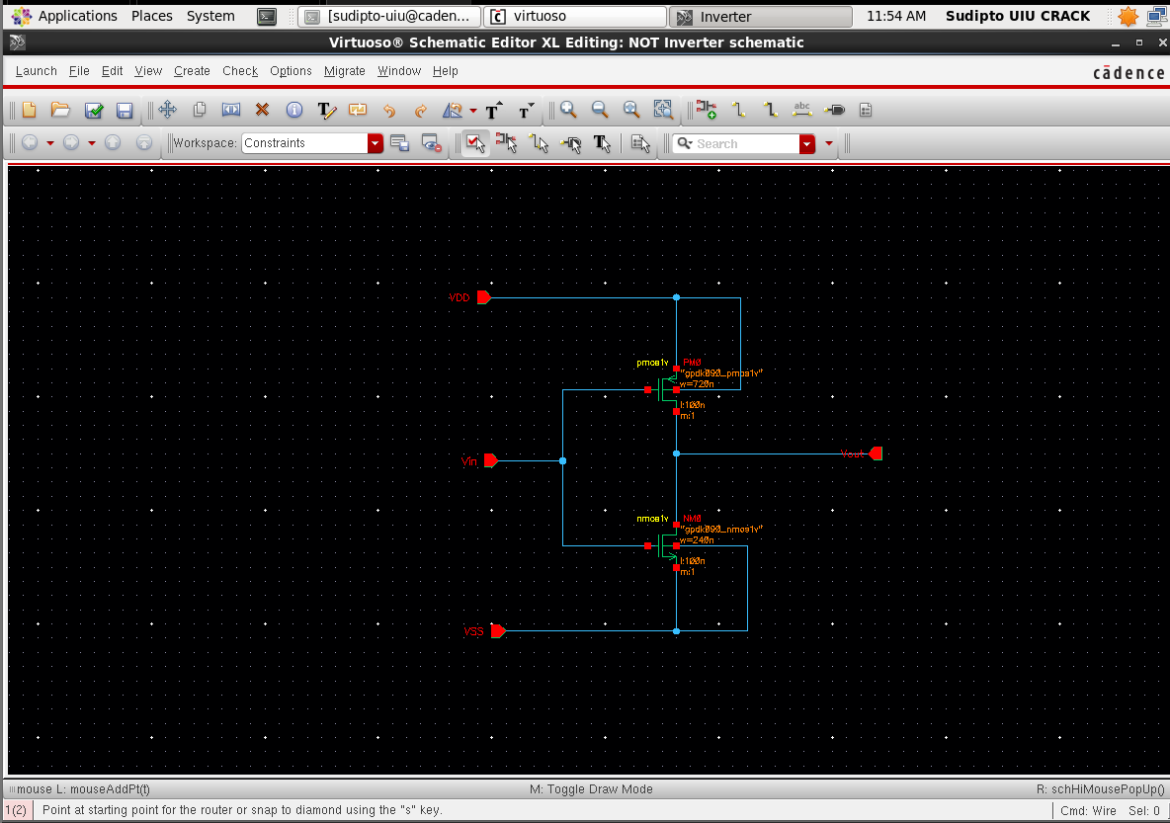
Figure-1.1. Complete transistor-level schematic of the CMOS NOT gate (NOT Inverter), showing the PMOS pull-up network (PM0, w=720n), the NMOS pull-down network (NM0, w=240n), and the Vin, Vout, VDD and VSS pins.

1.4.3 Schematic Symbol Generation and Test Bench Construction
After the schematic was checked and saved without errors, a schematic symbol was generated from the cellview using Create → Cellview → From Cellview. The default rectangular shape was replaced with the conventional triangle-and-bubble symbol for an inverter, with Vin placed as the left pin, Vout as the right pin, and VDD and VSS as the top and bottom pins respectively. A separate schematic, NOT Inverter_test, was then created to verify the NOT gate. The generated inverter symbol (labelled NOT) was instantiated, and a pulse voltage source (vpulse) from analogLib was connected to its input with voltage1 = 0 V, voltage2 = 1.8 V, period = 20 ns and pulse width = 10 ns. A DC voltage source (vdc) set to 1.8 V and a ground (gnd) were connected to the VDD and VSS pins respectively, and the input and output nets were named Vin and Vout using Create → Wire Name. The completed test bench, with the NOT gate symbol, all sources and net labels, is shown in Figure-1.2.

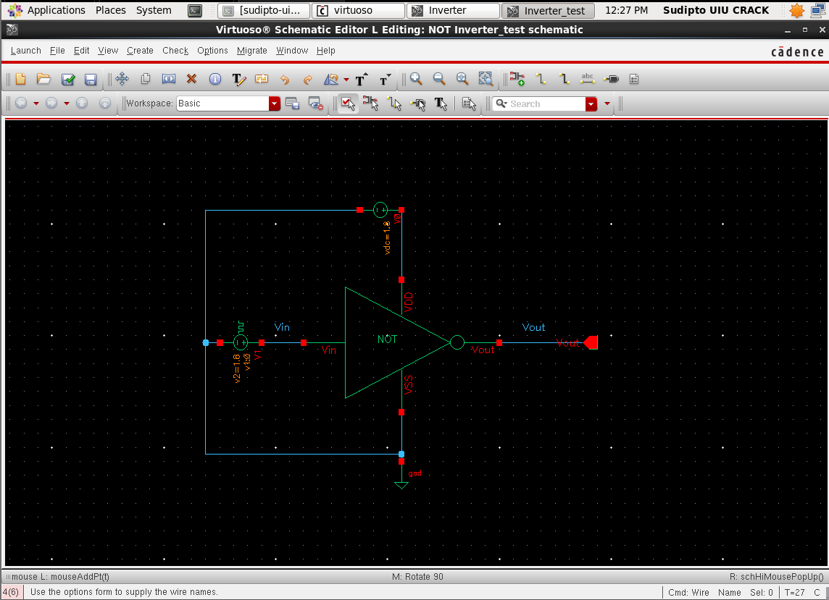
Figure-1.2. Test bench schematic (NOT Inverter_test) showing the instantiated NOT gate symbol (triangle with output bubble), the pulse input source (vpulse, 0–1.8 V, 20 ns period), the DC supply (vdc = 1.8 V), ground, and the Vin and Vout nets labeled.
1.4.4 Simulation Setup
The test bench was simulated in ADE L using the Spectre simulator, with the gpdk090 Spectre model library added under Setup → Model Libraries. A transient analysis was configured with a stop time of 100 ns, and a DC analysis was configured to sweep the DC voltage of the vpulse source from 0 V to 2.0 V, with the operating point saved. The input net Vin and the output net Vout were selected as the outputs to be plotted, and the simulation was run using Simulation → Netlist and Run.
1.4.5 Simulation Results: Input and Output Waveforms
Figure-1.3 shows the simulated transient response and the DC voltage transfer characteristic (VTC) of the NOT gate. In the transient response (left panel), Vin is a periodic pulse waveform switching between 0 V and 1.8 V with a 20 ns period and a 10 ns pulse width; Vout is observed to switch in the opposite sense, remaining close to 1.8 V while Vin is LOW and close to 0 V while Vin is HIGH across the full 100 ns simulation window, confirming correct NOT gate operation in every cycle. In the DC response (right panel), Vout decreases monotonically as Vin is swept from 0 V to 2.0 V, forming the characteristic S-shaped VTC curve. The switching threshold voltage VM, the point where the Vin diagonal line intersects the falling Vout curve, is observed close to the midpoint of the supply range (approximately VDD/2 ≈ 0.9 V), consistent with the 3:1 PMOS-to-NMOS sizing ratio used in the design.

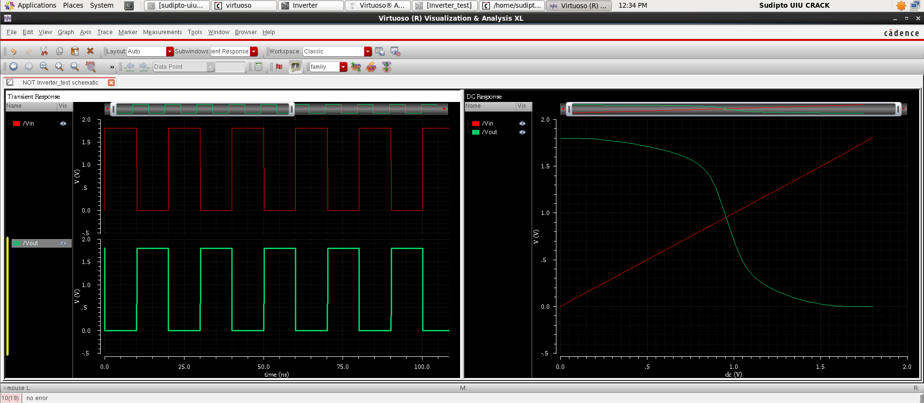
Figure-1.3. Simulation results: (left) transient response over 100 ns showing the pulse input Vin (red) and the inverted output Vout (green), and (right) the DC voltage transfer characteristic (VTC) of the CMOS NOT gate with the switching threshold near VDD/2.
1.5 Discussion
The discussion on the designed CMOS inverter circuit confirms its simulated behavior aligns with theoretical expectations. Transient simulations validated that the output waveform is the logical complement of the input pulse across a 100 ns window, consistent with the truth table. The DC simulation revealed a distinct voltage transfer characteristic with a sharp transition, and the switching threshold voltage was near the expected VDD/2 (approximately 0.9 V), successfully demonstrating that the PMOS transistor, sized three times wider than the NMOS, effectively addressed the PMOS's lower hole mobility. The circuit's design ensures negligible static power dissipation due to the pull-up and pull-down networks never being simultaneously active in steady-state operation.
Minor discrepancies in the switching threshold from the desired midpoint are attributed to device modeling and parasitic effects in the gpdk090 technology library. Extending the DC sweep to 2.0 V confirmed the output achieved optimal rail-to-rail levels in both logic states.
1.6 Conclusion
In this experiment, the CMOS NOT gate was designed at the transistor level using Cadence Virtuoso with NMOS and PMOS devices from the gpdk090 library, and its schematic symbol generated. The constructed test bench included a pulse input and a 1.8 V DC supply, and 100 ns transient and DC simulations with Spectre in ADE L verified the circuit's performance. Waveform observations confirmed the circuit’s effective execution of the logical NOT operation with rail-to-rail outputs. The extracted voltage transfer characteristic validated the transistor sizing strategy, confirming the efficient balance of drive strengths with the 3:1 PMOS-to-NMOS width ratio. This hands-on experiment enhanced understanding of the standard-cell schematic design flow foundational for future digital and mixed-signal IC designs.

